**Crime head-wise person arrested under crime against children during 2001-20120**

08-10-24

**─**

NUSRAT ZAHAN

01-025-20

**Overview**

This project has been made for the purpose to see the diversity of the number of arrested criminals against children in all the states in India during the year 2001-2010. After observing this project one can able to understand

* The up and down of these year
* The most popular number of crime head against children
* By showing bar chart comparison among years

**Goals**

1. To bring out the sum of arrested persons  of these  years individually
2. Make pivot table based on crime head and show cause the diversity by drawing bar chart
3. To analyze whether the number of arrested persons is a blessing or unfortunate.

**Introduction:**

Crime is a pervasive and complex issue that affects societies around the world. It encompasses a wide range of activities, from minor offenses to serious crimes like homicide and terrorism. The impact of crime extends beyond the immediate victims to families, communities, and entire nations, disrupting social order and economic stability. Among the various types of crime, those committed against children are particularly heinous and alarming.

Crimes against children, which include physical abuse, sexual exploitation, trafficking, neglect, and more, represent a significant and urgent problem. These crimes not only violate the fundamental rights of children but also have long-term detrimental effects on their physical, emotional, and psychological well-being. Children, due to their vulnerability and dependency on adults, are often unable to protect themselves or seek help, making them prime targets for perpetrators.

Governments and international organizations have recognized the severity of crimes against children and have established numerous laws, policies, and programs to combat these offenses. Despite these efforts, challenges remain in effectively preventing and addressing these crimes. The analysis of crime statistics, particularly head-wise data on the number of persons arrested for crimes against children, is crucial in understanding the scope of the problem and formulating effective interventions.

This project aims to explore the trends in crime and crimes against children in India from 2001 to 2012. By examining head-wise data on arrests, we can gain insights into the prevalence and patterns of these crimes, identify areas needing targeted intervention, and ultimately contribute to the development of strategies to protect the most vulnerable members of society.

**Analysis:**

Here we work for the crime head-wise persons arrested under crime against children during 2001-2012 in states of India .To find out the number of arrested person based on different crimes within India we select 495 data from 2001-2010 to analyze the rate.Then organize the data as below:

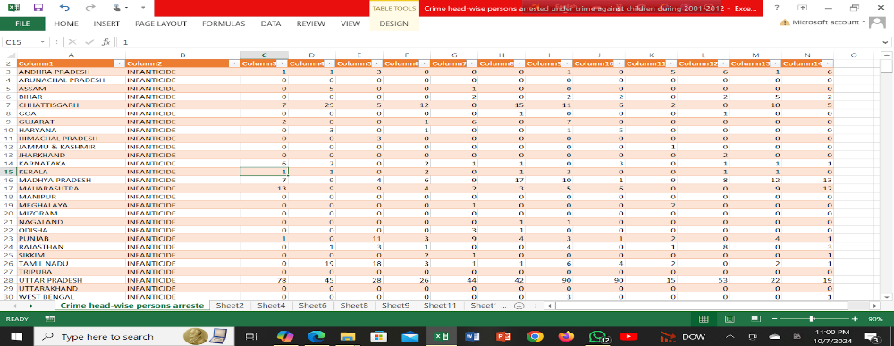

Taking all 495 datas like the table in excel, we take another sheet to analysis the data with the pivot table. After analysis the data we get the information as follows:

1. **Pivot Table:  Grouping Data based on crime heads**

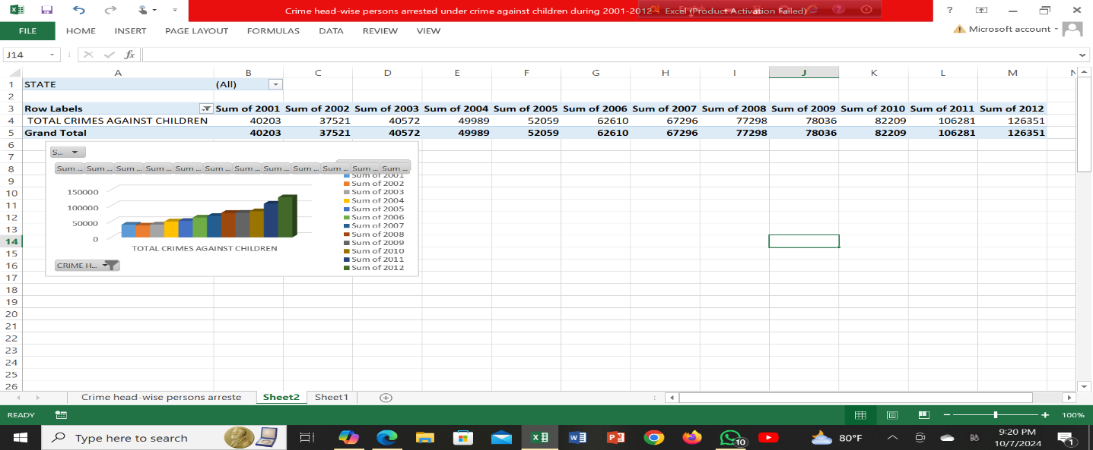Here we can see the sum of total crimes against children in 2001-2012.The lowest number of arrested persons belongs to 2002 and 2012 is stand for the highest number to catch perpetrators. In 2008 to 2010 the level is almost same.

1. **Pivot Table: Group data based upon Abetment of suicide**



Here 2001 hold the low number of arrested person against the crime abetment of suicide and top number in 2012.In 2004 and 2006 holds the same number of perpetrators.

3. Pivot Table:

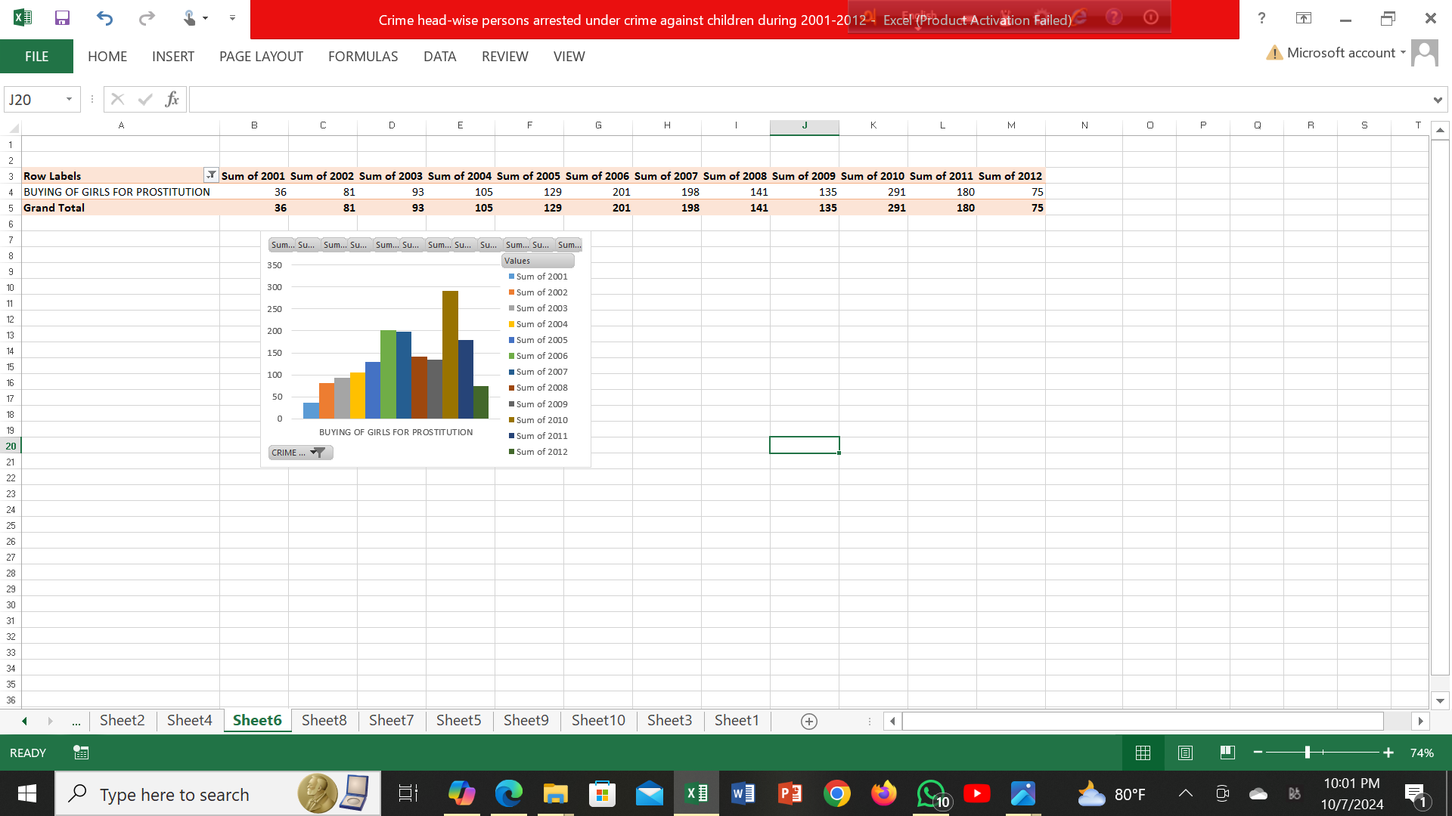

1. Pivot Table:

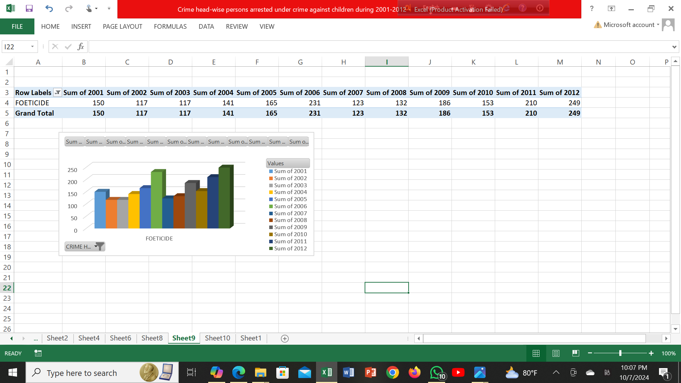

5. Pivot Table:

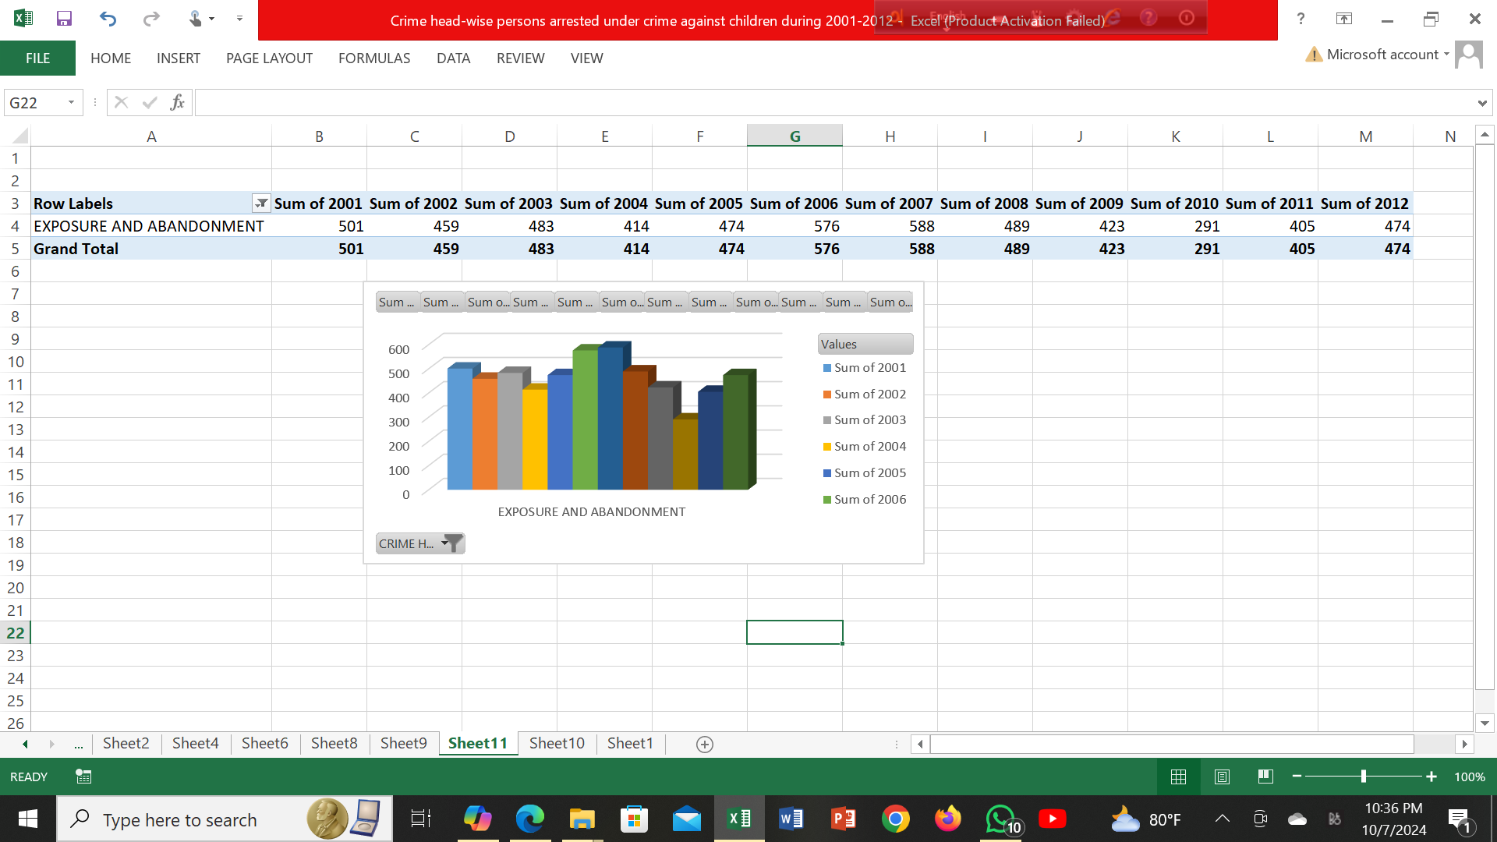

6. Pivot Table:

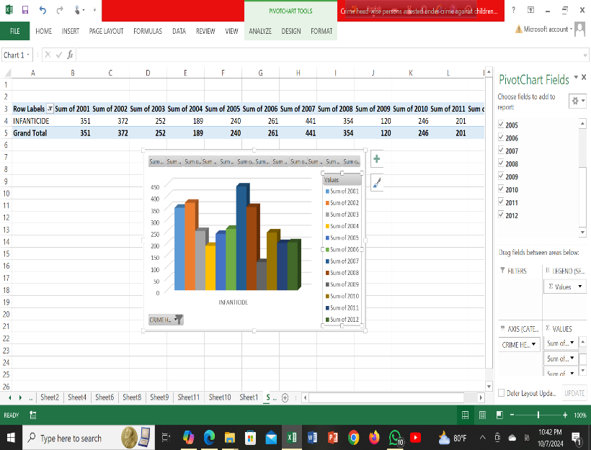

7.Pivot Table

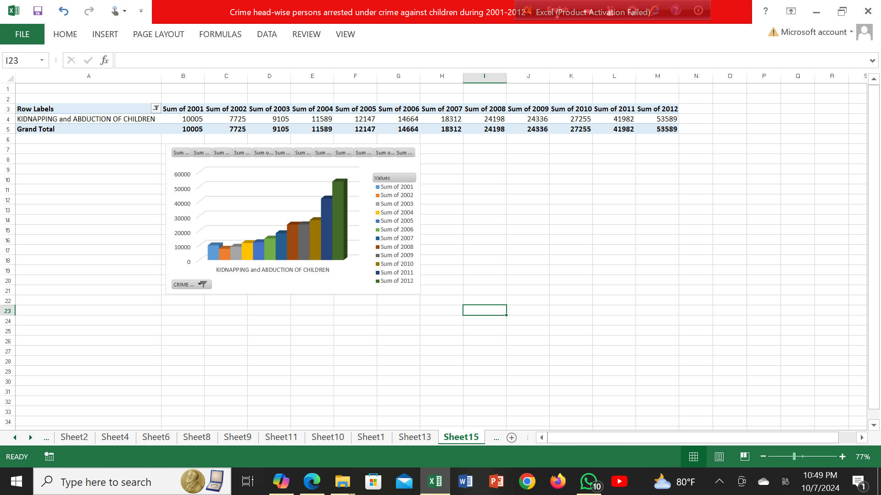

8.Pivot Table

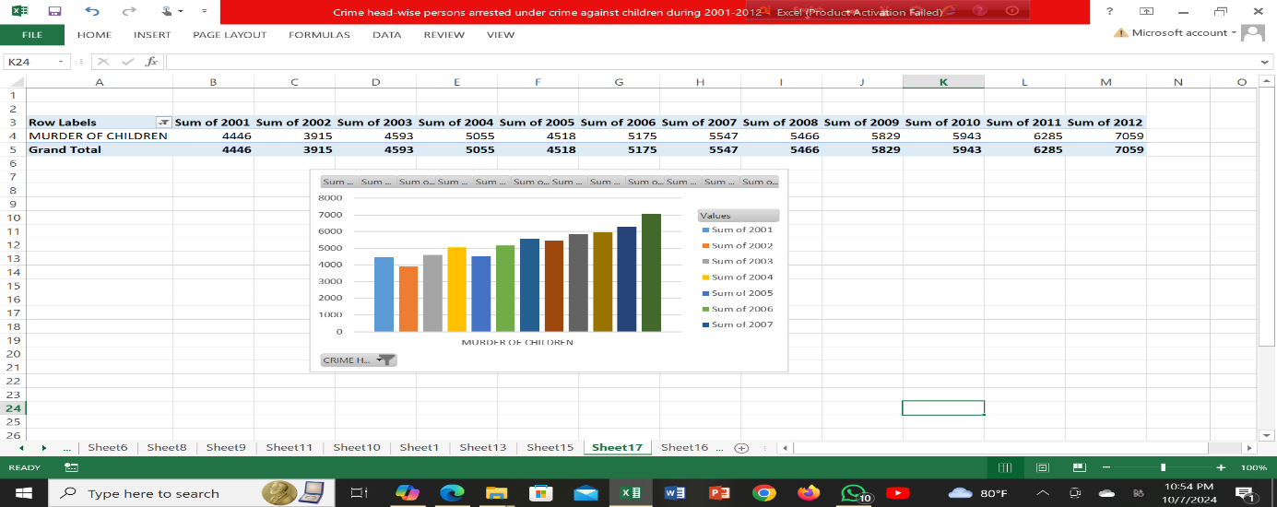

9. Pivot Table

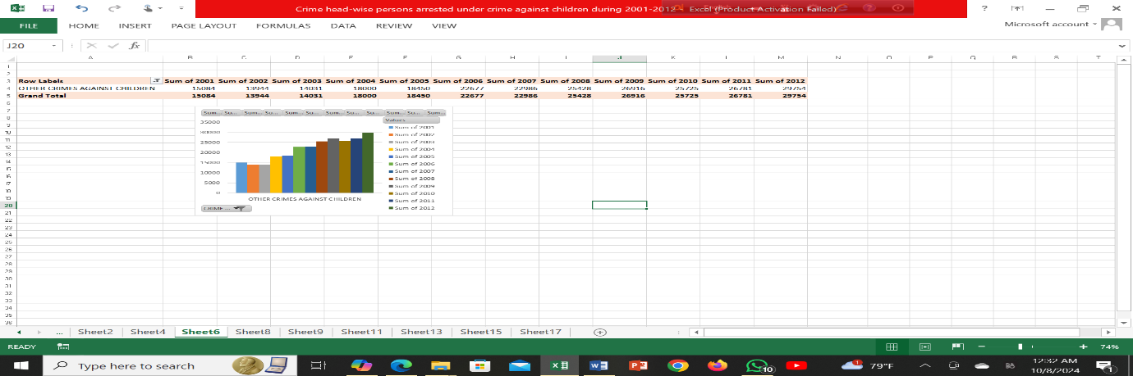

10.

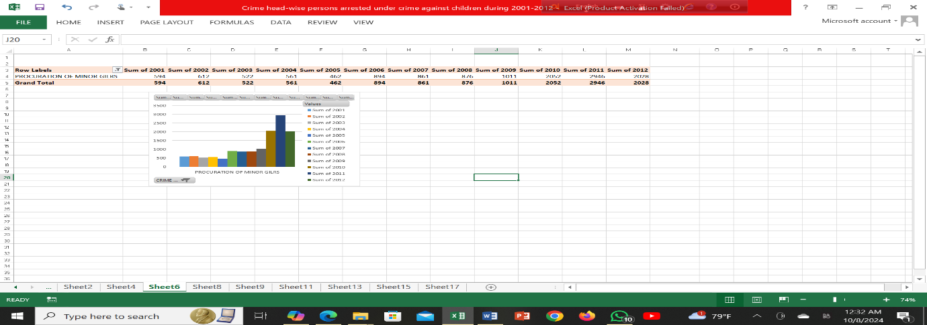

11.



12.

